Aim: Html program for inserting image form or local disk

Program:

<html>

<title> **Inserting Image** </title>

<body>

<img src=**"E:\html\20761A0589 html\Second Lab (02-11-2021)\Skeletonking.jpg"**

height= **"600"** width=**"1000"** alt=**"Skeleton King of Clash Royale"**/>

</body>

</html>

Output:

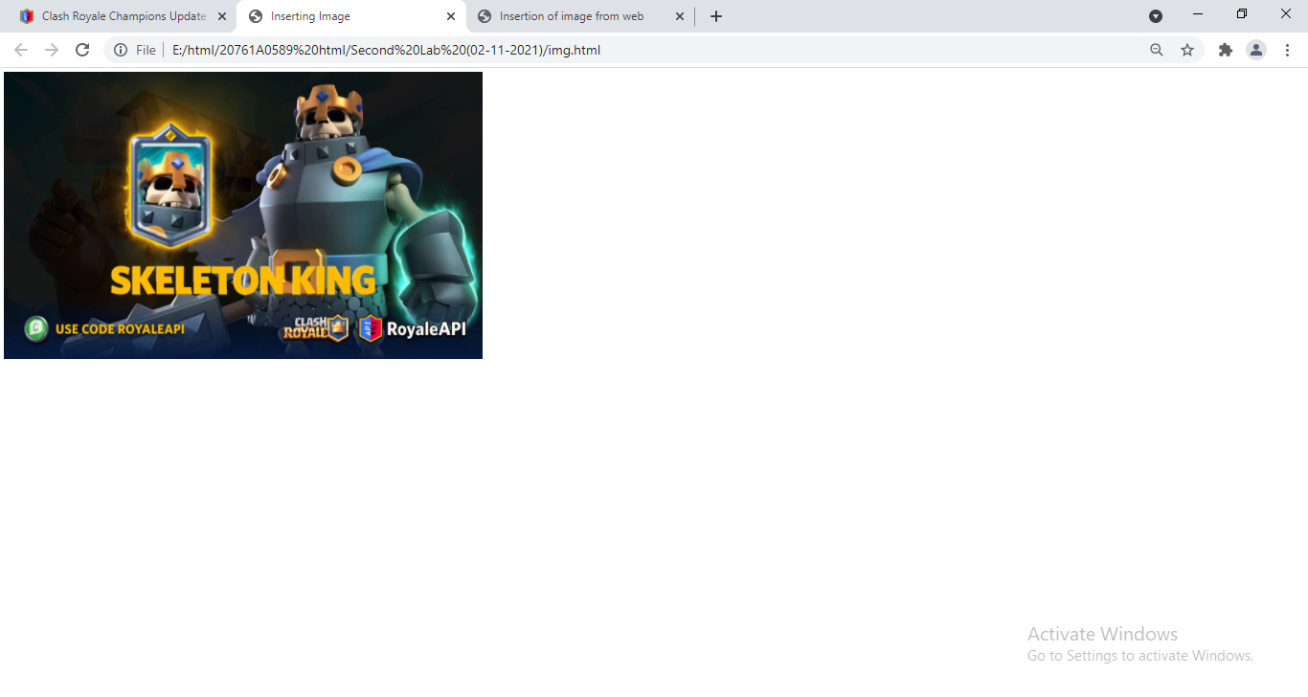

Aim: Inserting an image from the Internet source

Program:

<html>

<head><title> **Insertion of image from web** </title></head>

<body>

<img src=**"https://cdn.royaleapi.com/static/img/blog/2021-11-season29/champions-update/s29-master-004125-sm.jpg?t=47d52118c"**/>

</body>

</html>

Output:

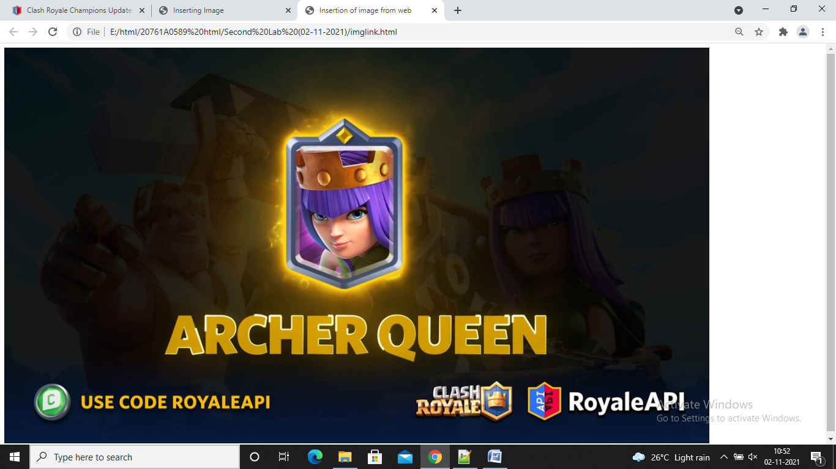

Aim: Using center tag to align image to center

Program:

<html>

<title> **Inserting Image** </title>

<body>

<center>

<img src=**"E:\html\20761A0589 html\Second Lab (02-11-2021)\Skeletonking.jpg"**

height= **"600"** width=**"1000"** alt=**"Skeleton King of Clash Royale"**/>

</center>

</body>

</html>

Output:

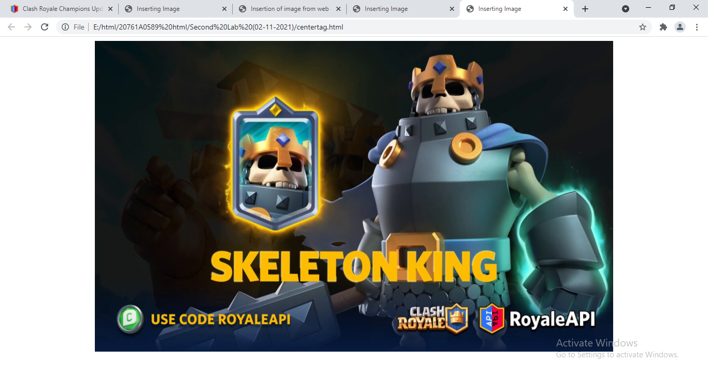

Aim: Using Table tag

Program:

<html>

<head>

<title> **Inserting table** </title>

</head>

<body>

<caption> **Table about Student** </caption>

<table border=**"5"** bordercolor=**"#0F0FF0"** width=**"400"** height=**"200"**>

<tr>

<th>**S.no**</th>

<th>**Student Name**</th>

<th>**Branch**</th>

</tr>

<tr>

<td>**1**</td>

<td>**Joshith**</td>

<td>**CSE**</td>

</tr>

<tr>

<td>**2**</td>

<td>**Srikanth**</td>

<td>**CSE**</td>

</tr>

<tr>

<td>**3**</td>

<td>**Kumar Sai**</td>

<td>**CSE**</td>

</tr>

<tr>

<td>**4**</td>

<td>**Murali Krishna**</td>

<td>**CSE**</td>

</tr>

</table>

</body>

</html>

Output:

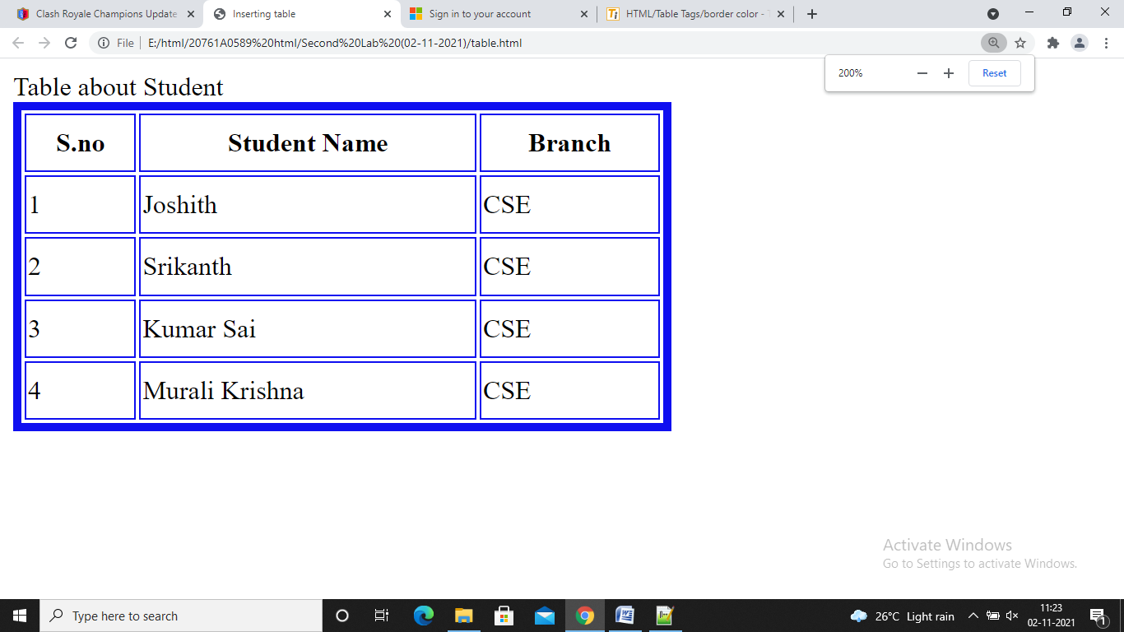

Aim: Using bgcolor for table

Program:

<html>

<head>

<title> **Inserting table** </title>

</head>

<body>

<caption> **Table about Student** </caption>

<table border=**"5"** bordercolor=**"#0F0FF0"** width=**"400"** height=**"200"** align=**'center'**>

<tr bgcolor=**"green"**>

<th>**S.no**</th>

<th>**Student Name**</th>

<th>**Branch**</th>

</tr>

<tr bgcolor=**"magenta"**>

<td>**1**</td>

<td bgcolor=**"red"**>**Joshith**</td>

<td>**CSE**</td>

</tr>

<tr bgcolor=**"yellow"**>

<td>**2**</td>

<td>**Srikanth**</td>

<td>**CSE**</td>

</tr>

<tr bgcolor=**"orange"**>

<td>**3**</td>

<td>**Kumar Sai**</td>

<td>**CSE**</td>

</tr>

<tr bgcolor=**"red"**>

<td>**4**</td>

<td>**Murali Krishna**</td>

<td>**CSE**</td>

</tr>

</table>

</body>

</html>

Output:

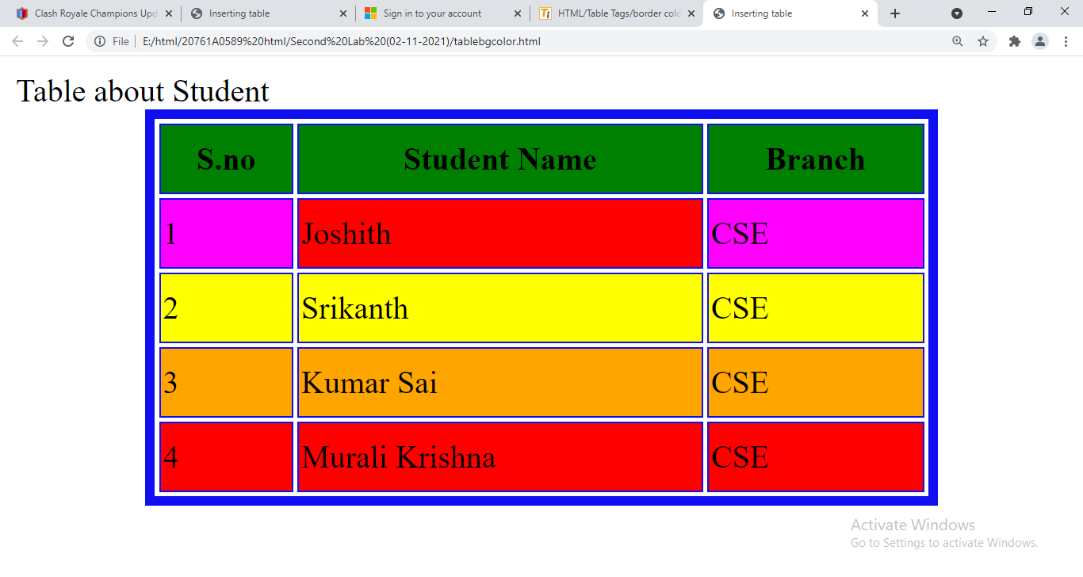

Aim: Using rowspan and colspan

Program:

<html>

<head>

<title> **Inserting table** </title>

</head>

<body>

<caption> **Table about Student** </caption>

<table border=**"5"** bordercolor=**"#0F0FF0"** width=**"400"** height=**"200"** align=**'center'**>

<tr bgcolor=**"green"**>

<th colspan=**"2"**>**S.no and Student Name**</th>

<th>**Branch**</th>

</tr>

<tr bgcolor=**"magenta"**>

<td colspan=**"2"**>**1 and Joshith**</td>

<td rowspan=**"4"**>**CSE**</td>

</tr>

<tr bgcolor=**"yellow"**>

<td>**2**</td>

<td>**Srikanth**</td>

</tr>

<tr bgcolor=**"orange"**>

<td>**3**</td>

<td>**Kumar Sai**</td>

</tr>

<tr bgcolor=**"red"**>

<td>**4**</td>

<td>**Murali Krishna**</td>

</tr>

<tr bgcolor=**"blue"**>

<td colspan=**"1"**> **Total** </td>

<td colspan=**"2"**> **4**</td>

</tr>

</table>

</body>

</html>

Output:

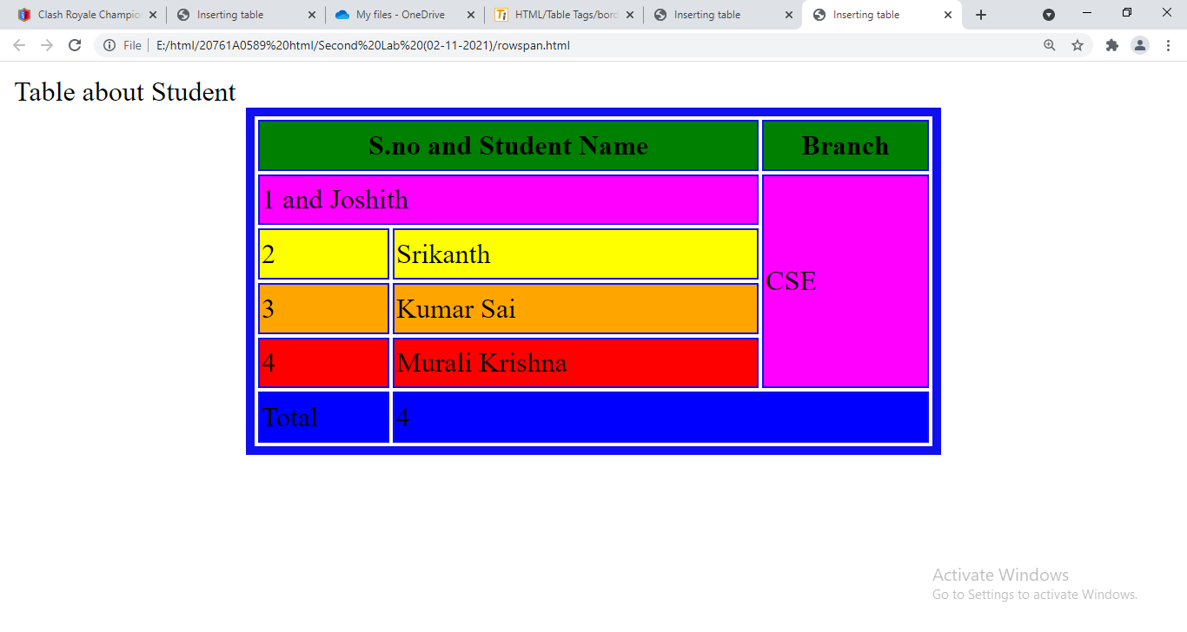

Aim: changing the font color of table using style from CSS

Program:

<html>

<head>

<title> **Inserting table** </title>

</head>

<body>

<caption> **Table about Student** </caption>

<table border=**"5"** bordercolor=**"#0F0FF0"** width=**"400"** height=**"200"** align=**'center'**>

<tr bgcolor=**"green"**>

<th colspan=**"2"**>**S.no and Student Name**</th>

<th>**Branch**</th>

</tr>

<tr bgcolor=**"magenta"**>

<td colspan=**"2"** style=**"color:red"**>**1 and Joshith**</td>

<td rowspan=**"4"**>**CSE**</td>

</tr>

<tr bgcolor=**"yellow"**>

<td>**2**</td>

<td style=**"color:blue"**>**Srikanth**</td>

</tr>

<tr bgcolor=**"orange"**>

<td>**3**</td>

<td>**Kumar Sai**</td>

</tr>

<tr bgcolor=**"red"**>

<td>**4**</td>

<td>**Murali Krishna**</td>

</tr>

<tr bgcolor=**"blue"**>

<td colspan=**"1"**> **Total** </td>

<td colspan=**"2"**> **4**</td>

</tr>

</table>

</body>

</html>

Output:

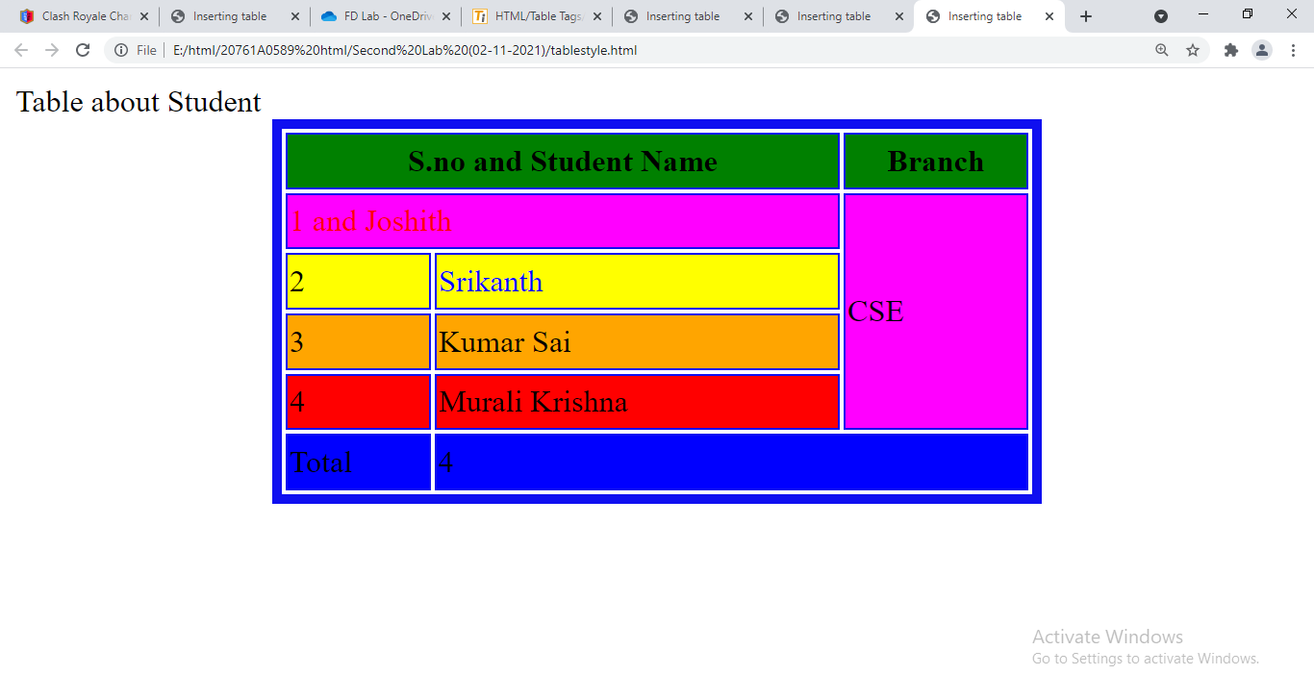

Aim: Using unorderlist

Program:

<html>

<body>

<ul>

<li> **C** </li>

<li> **C++** </li>

<li> **Java** </li>

<li> **Python** </li>

</ul>

</body>

</html>

Output:

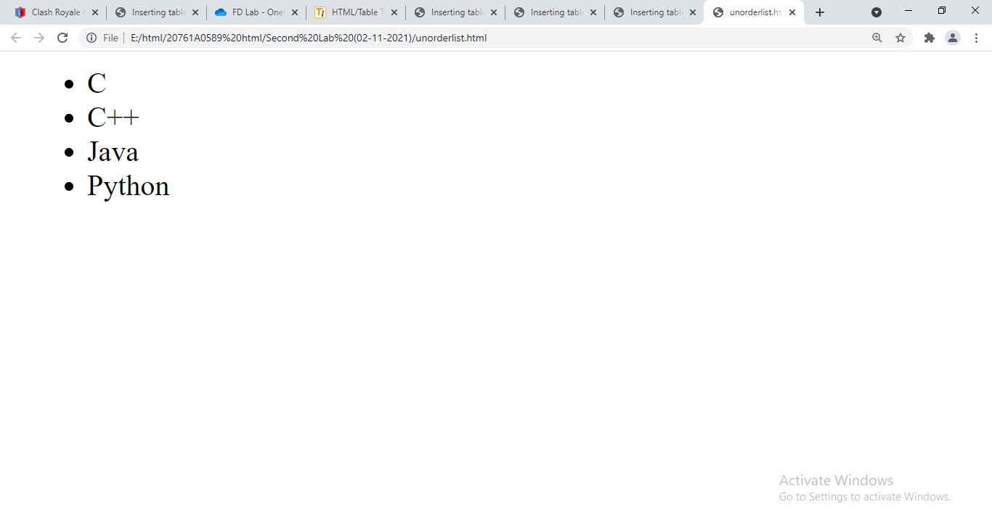

Aim: Using Order list

Program:

<html>

<body>

<ol>

<li> **C** </li>

<li> **C++** </li>

<li> **Java** </li>

<li> **Python** </li>

</ol>

</body>

</html>

Output:

